EXPERIMENT - 1

Configuration of Network Devices using Packet Tracer (Hub , Switch, Ethernet ,Router).

1. Using Hub

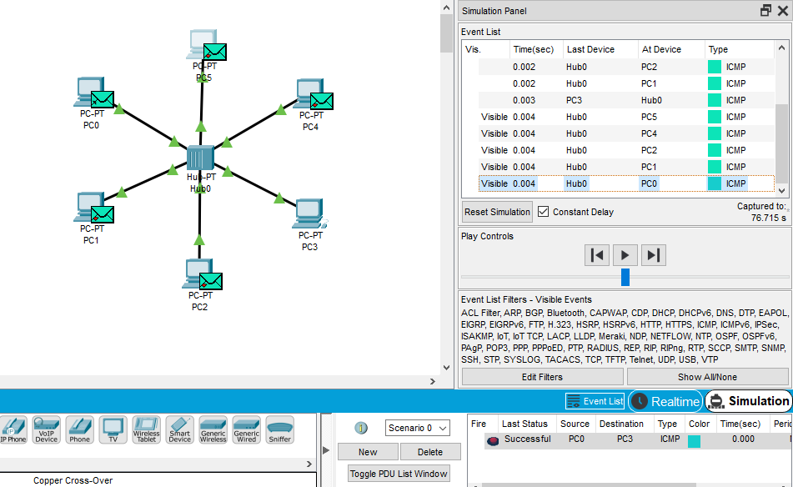

B) Using Switch

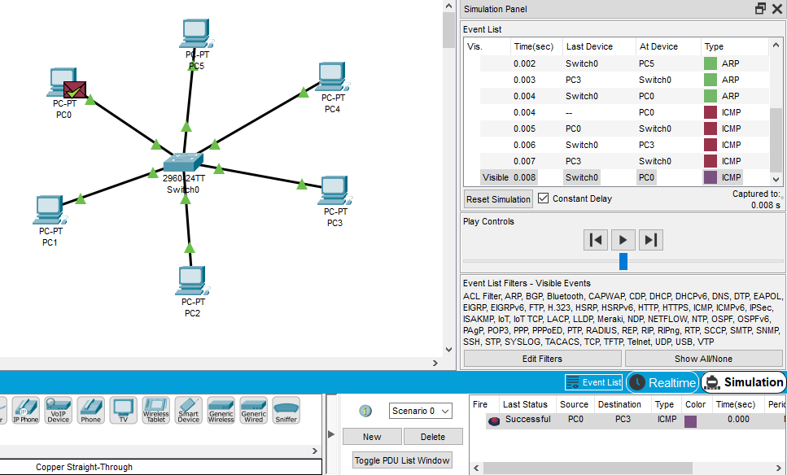

C) Using Router

